**SRI SIDDHARTHA ACADEMY OF HIGHER EDUCATION**

## *(Declared as Deemed to be University Under Section 3 of the UGC Act 1956)*

## AGALKOTE, TUMAKURU–572107

## KARNATAKA

#### Mini Project Report

#### On,

**“FACIAL RECOGNITION ATTENDANCE SYSTEM USING PYTON AND OPEN CV”**

**Submitted by:**

**THEJUS G C (18IS078)**

**DEEPAK T K (19IS401)**

**Under the Guidance of:**

**PRASANNA KUMAR M** (B .E., M.Tech.,(Ph.D).MISTE)

Asst.Prof, Dept of ISE,

SSIT, TUMAKURU – 572105

**DEPARTMENT OF INFORMATION SCIENCE & ENGINEERING**

**SRI SIDDHARTHA INSTITUTE OFTECHNOLOGY**

**SRI SIDDHARTHA INSTITUTE OF TECHNOLOGY**

**(A Constituent college of Sri Siddhartha Academy of Higher Education)**

SRI SIDDHARTHA INSTITUTE OF TECHNOLOGY

(A Constituent College of Sri Siddhartha Academy of Higher Education Approved by AICTE, Accredited by NBA, NAAC with ‘A ’Grade)

MARALUR, TUMAKURU-572105

DEPARTMENT OF INFORMATION SCIENCE AND ENGINEERING



**CERTIFICATE**

*Certified that the Mini project work entitled carried out by “****Thejus G C ,Deepak T K****” USN 18IS078,19IS401 of the Sri Siddhartha Institute of technology, Tumakuru during the year 2020 – 21. It is certified that all corrections/suggestions indicated for Internal Assessment have been incorporated in the Report deposited in the departmental library.*

*The project report has been approved as it satisfies the academic requirements in respect of Project work prescribed for the said Degree.*

|  |  |  |
| --- | --- | --- |
| **Signature of the Guide** | **Signature of the HOD** | **Signature of the Principal** |
| **Prasanna Kumar M** | **Dr. Karunakara.K** | **Dr. M.S Raviprakasha** |
| B .E., M.Tech.,(Ph.D).MISTE, | B.E., M.Tech, Ph.D. | B.E, M.Tech., Ph.D., FIE,. |
| Assistant Professor, Dept of ISE | Dean (Examination) & HOD, Dept of ISE | Principal, SSIT, |
| SSIT, Tumakuru | SSIT, Tumakuru | Tumakuru |
|  |  |  |

# ACKNOWLEDGEMENT

At the outset we express our most sincere grateful thanks to holy sanctum of **“SRI SIDDHARTHA INSTITUTE OF TECHNOLOGY”**, the temple of learning, for giving us an opportunity to pursue the degree course in Information Science and Engineering thus help shaping our career.

We wish to express my sincere gratitude to **Dr. M. S. RAVIPRAKASHA** Principal, Sri Siddhartha Institute of Technology, for providing us an excellent academic environment, which has nurtured our practical skills, and for kindly obliging our requests and providing timely assistance.

We are highly grateful to **Dr. KARUNAKARA.K,** Dean Examination and Head of Department of Information Science and Engineering, for patronizing us throughout the project and for his encouragement and moral support.

We also wish to express our deep sense of gratitude to our project guide **PRASANNA KUMAR.M,** Assistant Professor, Department of Information Science and Engineering, for his valuable suggestions, guidance, moral support and encouragement in completion of this project successfully. We have been fortunate for having her precious help.

Finally, we express our gratitude to all the teaching and non-teaching of the **Information Science and Engineering Department** staff for their timely support and suggestions.

We are also thankful to our parents for their moral support and constant guidance made our efforts fruitful. Last but not the least, our friends, without their constructive criticisms and suggestions we wouldn’t have been able to complete successfully.

**CONTENTS:**

* **Abstract**
* **Introduction**
* **Literature**
* **Objective**
* **Methodology**
* **Enrolment**
* Face Detection And Recognition:
* **Attendance Marking**
* Advantages of Facial Recognition for Attendance:
* **Source Code**
* **Requirements**
* **Conclusion**

**Abstract:**

The main purpose of this project is to build a face recognition-based attendance monitoring system for educational institution to enhance and upgrade the current attendance system into more efficient and effective as compared to before. The current old system has a lot of ambiguity that caused inaccurate and inefficient of attendance taking. Many problems arise when the authority is unable to enforce the regulation that exists in the old system. The technology working behind will be the face recognition system. The human face is one of the natural traits that can uniquely identify an individual. Therefore, it is used to trace identity as the possibilities for a face to deviate or being duplicated is low. In this project, face databases will be created to pump data into the recognizer algorithm. Then, during the attendance taking session, faces will be compared against the database to seek for identity. When an individual is identified, its attendance will be taken down automatically saving necessary information into an excel sheet. At the end of the day, the excel sheet containing attendance information regarding all individuals are mailed to the respective faculty. The management of the attendance can be a great burden on the teachers if it is done by hand. To resolve this problem, smart and auto attendance management system is being utilized. By utilizing this framework, the problem of proxies and students being marked present even though they are not physically present can easily be solved. This system marks the attendance using live video stream. The frames are extracted from video using Open CV. The main implementation steps used in this type of system are face detection and recognizing the detected face, for which dlib is used. After these, the connection of recognized faces ought to be conceivable by comparing with the database containing student's faces. This model will be a successful technique to manage the attendance of students.

**Introduction:**

This is a project about Facial Recognition-Based Attendance System for Educational Institutions. According to the previous attendance management system, the accuracy of the data collected is the biggest issue. This is because the attendance might not be recorded personally by the original person, in another word, the attendance of a particular person can be taken by a third party without the realization of the institution which violates the accuracy of the data. For example, student A is lazy to attend a particular class, so student B helped him/her to sign for the attendance which in fact student A didn’t attend the class, but the system overlooked this matter due to no enforcement practiced. Supposing the institution establish enforcement, it might need to waste a lot of human resource and time which in turn will not be practical at all. Thus, all the recorded attendance in the previous system is not reliable for analysis usage. The second problem of the previous system is where it is too time consuming. Assuming the time taken for a student to sign his/her attendance on a 3-4 paged name list is approximately 1 minute. In 1 hour, only approximately 60 students can sign their attendance which is obviously inefficient and time consuming. The third issue is with the accessibility of those information by the legitimate concerned party. For an example, most of the parents are very concerned to track their child’s actual whereabouts to ensure their kid really attend the classes in college/school. However in the previous system, there are no ways for the parents to access such information. Therefore, evolution is needed to be done to the previous system to improve efficiency, data accuracy and provides accessibility to the information for those legitimate party. Human face plays an important role in our day to day life mostly for identification of a person. Face recognition is a part of biometric identification that extracts the facial features of a face, and then stores it as a unique face print to uniquely recognize a person. Biometric face recognition technology has gained the attention of many researchers because of its wide application. Face recognition technology is better than other biometric based recognition techniques like finger-print, palm-print, iris because of its non-contact process. Recognition techniques using face recognition can also recognize a person from a distance, without any contact or interaction with person. The face recognition techniques are currently implemented in social media websites like Facebook, at the airports, railway stations. The, at crime investigations. Face recognition technique can also be used in crime reports, the captured photo can be stored in a database, and can be used to identify a person. Facebook uses the facial recognition technique for automating the process of tagging people. For face recognition we require large dataset and complex features to identify a person in all conditions like change of illumination, age, pose, etc. Recent researches show there is a betterment in facial recognition systems. In the last ten years there is huge development in recognition techniques. But currently most of the facial recognition techniques is able to work fine only if the number of people in one frame is very few and under controlled illumination, proper position of faces and clear images. For face recognition purpose, there is a need for large data sets and complex features to uniquely identify the different subjects by manipulating different obstacles like illumination, pose and aging. During the recent few years, a good improvement has been made in facial recognition systems. In comparison to the last decade, one can observe an enormous development in the world of face recognition. Currently, most of the facial recognition systems perform well with limited faces in the frame. Moreover, these methodologies have been tested under controlled lighting conditions, proper face poses and non- blurry images. The system that is proposed for face recognition in this paper for attendance system is able to recognize multiple faces in a frame without any control on illumination, position of face.

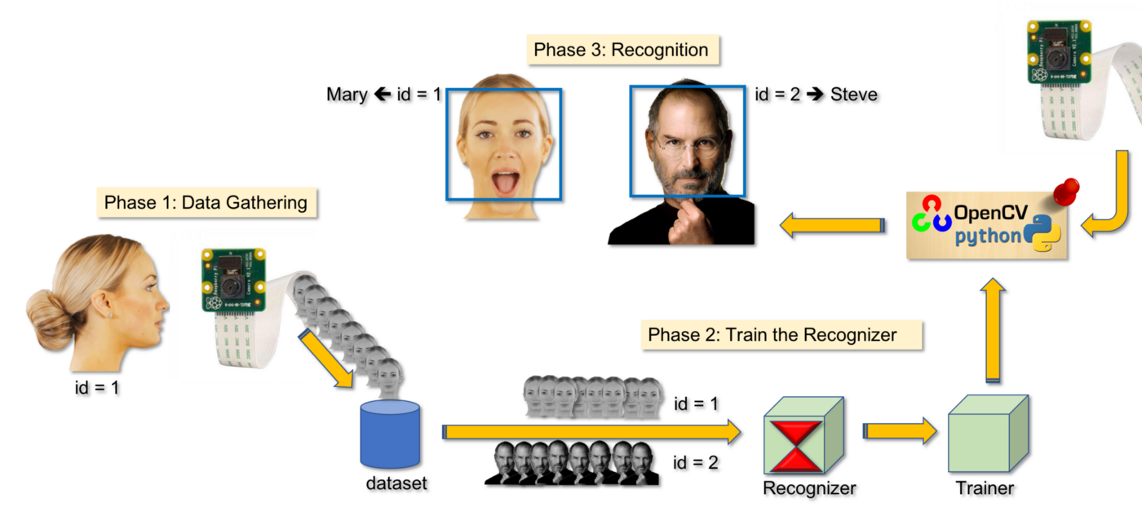

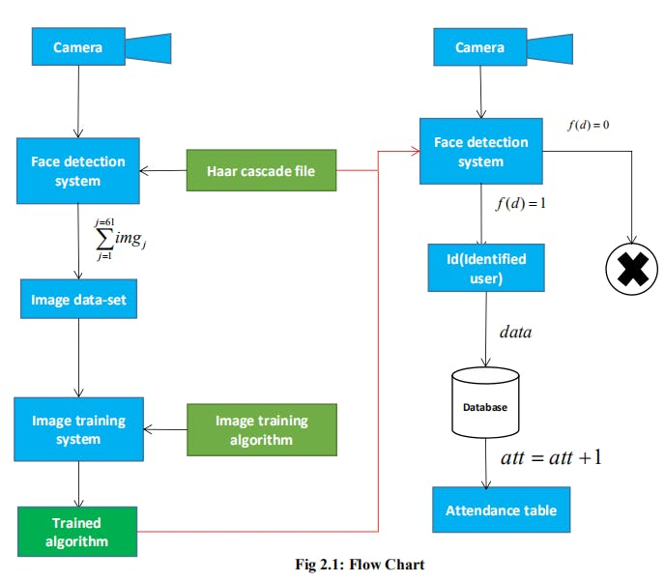

**Literature:**

▪ Students will be more punctual on attending classes. This is due to the attendance of a student can only be taken personally where any absentees will be noticed by the system. This can not only train the student to be punctual as well as avoids any immoral ethics such as signing the attendance for their friends.

▪ The institution can save a lot of resources as enforcement are now done by means of technology rather than human supervision which will waste a lot of human resource for an insignificant process.

▪ The application can operate on any device at any location as long as there is Wi-Fi coverage or Ethernet connection which makes the attendance system to be portable to be placed at any intended location. For an example, the device can be placed at the entrance of the classroom to take the attendance.

▪It saves a lot of cost in the sense that it had eliminated the paperwork completely.

▪ The system is also time effective because all calculations are all automated. In short, the project is developed to solve the existing issues in the old attendance system.

**Objective:**

▪ To develop a portable Smart Attendance System which is handy and self-powered.

▪ To ensure the speed of the attendance recording process is faster than the previous system which can go as fast as approximately 3 second for each student.

▪ Have enough memory space to store the database.

▪Able to recognize the face of an individual accurately based on the face database.

▪ Allow parents to track their child’s attendance.

▪ Develop a database for the attendance management system.

▪ Provide a user-friendly interface for admins to access the attendance database and for non-admins (parents) to check their child’s attendance by mailing the attendance.

▪ Allow new students or staff to store their faces in the database by using a GUI.

▪ Able to show an indication to the user whether the face- recognition process is successful or not.

**Methodology:**

In order to mark attendance, we follow a series of steps which includes enrolment, face detection, face recognition, and then marking the attendance in a database. Unlike Eigenfaces and Fisherfaces, where in most modern face verification systems, training and enrolment are two different steps. Training is performed on millions of images. On the other hand, enrolment is performed using a small set of images. In case of Dlib, enrolling a person is simply passing a few images of the person through the network to obtain 128- dimensional feature descriptors corresponding to each image. In other words, we convert each image to a feature in a high-dimensional space. In this high dimensional space, features belonging to the same person will be close to each other and far away for different persons.

**Enrolment:**

For enrolment we define smaller ResNet neural network. Training was also done using this network. A Person images we are going to enrol are structured in following way: We will be having sub folders, each subfolder has images of one person. We will store this mapping of images and their corresponding labels to use it later in testing. Then we process enrolment images one by one, convert each image from BGR to RGB format, because Dlib uses RGB as default format. Then convert Open CV BGR image to Dlibs cv_image and then Dlibs cv_image to Dlibs matrix format since Dlibs cv_image format is not recognized by neural network module. Detect faces in the image. For each face we detect facial landmarks and get a normalized and warped patch of detected face. Compute face descriptor using facial landmarks. This is a 128- dimensional vector which represents a face. Then save labels and names to disk and face descriptors and corresponding labels to disk.

**Face Detection And Recognition:**

Given a new image of a person, we can verify if it is the same person by checking the distance between the enrolled faces and the new face in the 128-dimensional space. Read name-labels mapping and descriptors from disk. Then read the query image that is an image of classroom with multiple students and convert it from BGR to RGB format. Because Dlib uses RGB as default format. Then convert Open CV RGB image to Dlibs cv_image, and then Dlibs cv_image to Dlibs matrix format. Dlibs cv_image format is not recognized by neural network module. Detect faces in query image. For each face detect facial landmarks. Get a warped and patch of 150×150 for each face. Now compute face descriptor for each face. Now we calculate Euclidean distance between face descriptors in query images versus face descriptors of enrolled images. Find the enrolled face for which distance is minimum. Dlib specifies that in general, if two face descriptor vectors have a Euclidean distance between them less than 0.6 then they are from the same person, otherwise they are from different people. This threshold will vary depending upon number of images enrolled and various variations (illumination, camera quality) between enrolled images and query image. We are using a threshold of 0.5. If minimum distance is less than threshold, find the name of person from index, else the person in query image is unknown.

**Attendance Marking:**

For each face detected and matched with enrolled face, the attendance is marked for the corresponding USN in the database. The name of student along with day and time of attendance is also be stored in the database.

**Advantages of Facial Recognition for Attendance:**

* The system helps to track the individual employee mistakes on attendance and helps to improve the number of working hours of an employee. The system can calculate each timing of employees and sends the data to the admin.
* The face recognition technology can determine the precise calculation of employees attendance and absenteeism in every single stage of possible. It can match millions of images stored in the database. As technology helps to save the time of management to collect all the data of employee attendance details.
* This technology helps to avoid an unknown person of punching instead of belonging employees. The face recognition helps to scan the face and makes the job easy to identify that each and every human walks in the work area.
* The method of face recognition clock is a wonderful option to reduce the scattering of infections plus disease. Consequently, holding teams healthful. While employees are fit, they go to the job, and are in enhanced conditions, and improve their production.
* Facial recognition systems are very simple to fix. You can easily connect one of the best benefits of Integrated Biometric facial designs. These are clear towards programming into your firm’s PC operation. Most of the methods would serve with the software that you have by now established.

**SOURCE CODE:**

import cv2

import numpy as np

import face_recognition

import os

from datetime import datetime

**# from PIL import ImageGrab**

path = 'ImagesAttendance'

images = []

classNames = []

myList = os.listdir(path)

print(myList)

for cl in myList:

curImg = cv2.imread(f'{path}/{cl}')

images.append(curImg)

classNames.append(os.path.splitext(cl)[0])

print(classNames)

def findEncodings(images):

encodeList = []

for img in images:

img = cv2.cvtColor(img, cv2.COLOR_BGR2RGB)

encode = face_recognition.face_encodings(img)[0]

encodeList.append(encode)

return encodeList

def markAttendance(name):

with open('Attendance.csv','r+') as f:

myDataList = f.readlines()

nameList = []

for line in myDataList:

entry = line.split(',')

nameList.append(entry[0])

if name not in nameList:

now = datetime.now()

dtString = now.strftime('%H:%M:%S')

f.writelines(f'n{name},{dtString}')

**#### FOR CAPTURING SCREEN RATHER THAN WEBCAM**

# def captureScreen(bbox=(300,300,690+300,530+300)):

# capScr = np.array(ImageGrab.grab(bbox))

# capScr = cv2.cvtColor(capScr, cv2.COLOR_RGB2BGR)

# return capScr

encodeListKnown = findEncodings(images)

print('Encoding Complete')

cap = cv2.VideoCapture(0)

while True:

success, img = cap.read()

#img = captureScreen()

imgS = cv2.resize(img,(0,0),None,0.25,0.25)

imgS = cv2.cvtColor(imgS, cv2.COLOR_BGR2RGB)

facesCurFrame = face_recognition.face_locations(imgS)

encodesCurFrame = face_recognition.face_encodings(imgS,facesCurFrame)

for encodeFace,faceLoc in zip(encodesCurFrame,facesCurFrame):

matches = face_recognition.compare_faces(encodeListKnown,encodeFace)

faceDis = face_recognition.face_distance(encodeListKnown,encodeFace)

#print(faceDis)

matchIndex = np.argmin(faceDis)

if matches[matchIndex]:

name = classNames[matchIndex].upper()

y1,x2,y2,x1 = faceLoc

y1, x2, y2, x1 = y1*4,x2*4,y2*4,x1*4

cv2.rectangle(img,(x1,y1),(x2,y2),(0,255,0),2)

cv2.rectangle(img,(x1,y2-35),(x2,y2),(0,255,0),cv2.FILLED)

cv2.putText(img,name,(x1+6,y2-6),cv2.FONT_HERSHEY_COMPLEX,1,(255,255,255),2)

markAttendance(name)

cv2.imshow('Webcam',img)

cv2.waitKey(1)

**Requirements:**

**Software Requirements:**

* Database
* MySQL
* IDLE Python

**Hardware Requirements:**

* Processor
* RAM
* Hard disk
* Monitor
* Keyboard

**Specification:**

* Pentium III 630MHz
* 128 MB RAM
* 20 GB ROM
* 15" colour monitor

**CONCLUSION:**

To improve the recognition performance, there are MANY things that can be improved here, some of them being fairly easy to implement. For example, you could add colour processing, edge detection, etc. You can usually improve the face recognition accuracy by using more input images, at least 50 per person, by taking more photos of each person, particularly from different angles and lighting conditions. If you can’t take more photos, there are several simple techniques you could use to obtain more training images, by generating new images from your existing ones: You could create mirror copies of your facial images, so that you will have twice as many training images and it won’t have a bias towards left or right. You could translate or resize or rotate your facial images slightly to produce many alternative images for training, so that it will be less sensitive to exact conditions. You could add image noise to have more training images that improve the tolerance to noise. It is important to have a lot of variation of conditions for each person, so that the classifier will be able to recognize the person in different lighting conditions and positions, instead of looking for specific conditions. But it’s also important to make sure that a set of images for a person is not too varied, such as if you rotated some images by 90 degrees. This would make the classifier to be too generic and also give very bad results, so if you think you will have a set of images with too much variance (such as rotation more than 20 degrees), then you could create separate sets of training images for each person. For example, you could train a classifier to recognize "John_Facing_Forward" and another one for "John_Facing_Left" and other ones "Mary_Facing_Forward", "Mary_Facing_Left", etc. Then each classifier can have a lot of variance but not too much, and you simply need to associate the different classifiers for each person with that one person (i.e.: "John" or "Mary"). That's why you can often get very bad results if you don't use good pre-processing on your images. As I mentioned earlier, Histogram Equalization is a very basic image pre-processing method that can make things worse in some situations, so you will probably have to combine several different methods until you get decent results. And something important to understand is that at the heart of the algorithm, it is matching images by basically doing the equivalent of subtracting the testing image with a training image to see how similar they are. This would work fairly well if a human performed it, but the computer just thinks in terms of pixels and numbers. So if you imagine that it is looking at one pixel in the test image, and subtracting the gray scale value of that pixel with the value of the pixel in the EXACT same location of each training image, and the lower the difference then the better the match. So if you just move an image by a few pixels across, or use an image that is just a few pixels bigger or has a few more pixels of the forehead showing than the other image, etc., then it will think they are completely different images! This is also true if the background is different, because the code doesn't know the difference between background and foreground (face), which is why it’s important to crop away as much of the background as you can, such as by only using a small section inside the face that doesn't include any background at all. Since the images should be almost perfectly aligned, it actually means that in many cases, using small low-res images (such as by shrinking the images to thumbnail size) can give better recognition results than large hi-res images! Also, even if the images are perfectly aligned, if the testing image is a bit brighter than the training image then it will still think there is not much of a match. Histogram Equalization can help in many cases but it can also make things worse in other cases, so differences in lighting is a difficult & common problem. There are also issues such as if there was a shadow on the left of the nose in the training image and on the right in the test image then it will often cause a bad match, etc. That's why face recognition is relatively easy to do in real-time if you are training on someone and then instantly trying to recognize them after, since it will be the same camera, and background will be the same, their expressions will be almost the same, the lighting will be the same, and the direction you are viewing them from will be the same. So you will often get good recognition results at that moment. But once you try to recognize them from a different direction or from a different room or outside or on a different time of the day, it will often give bad results! So it’s important to do a lot of experimentation if you want better results, and if you still can't get good results after trying many things, perhaps you will need a more complicated face recognition algorithm than PCA (Eigenfaces), such as 3D Face Recognition or Active Appearance Models, mentioned below.